

**School of Engineering and Applied Science,**

**Ahmedabad University**

**CSE300 Software Engineering**

**Weekly Report**

**Guided By: Prof Khushru Doctor**

**TA Muskan Matwani**

**TA Anupama Nair**

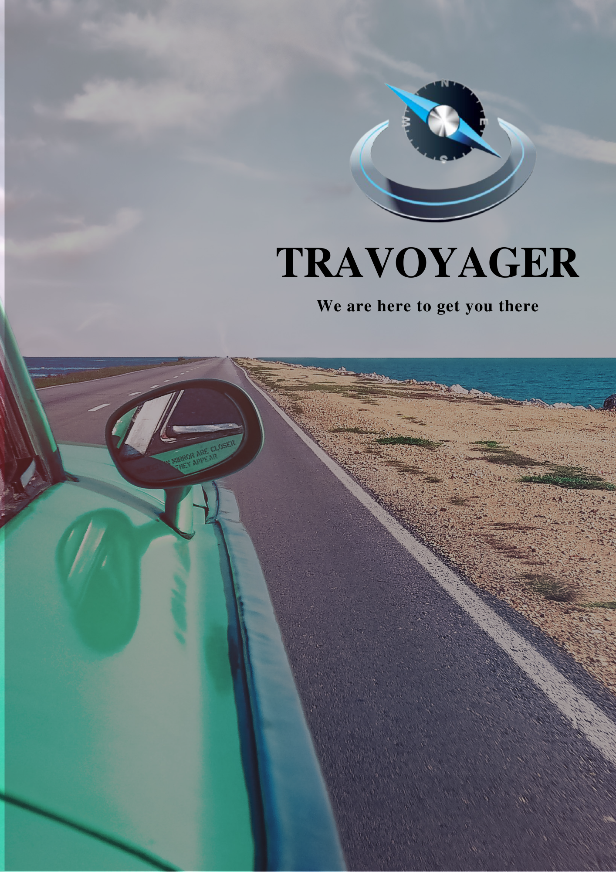

**WEEKLY MEETING REPORT - 7**

**Agenda** - Sprint 2 Discussion

**Date and Time**

**________________________________________________________________________________________________________________________________________________________________________________________________________________________________________________________________________________________________________________________________________________________________________________________________________________________________**

March 21, 2021 11:00 A.M.-12:00P.M.

**Location**

**________________________________________________________________________________________________________________________________________________________________________________________________________________________________________________________________________________________________________________________________________________________________________________________________________________________________**

Google Meet

**Schedule**

**________________________________________________________________________________________________________________________________________________________________________________________________________________________________________________________________________________________________________________________________________________________________________________________________________________________________**

|  |  |
| --- | --- |
| **Time** | **Description** |
| 11:00-11:05 A.M. | Attendance |
| 11:05-11:30 A.M. | Progress Sharing |
| 11:30-11:45 A.M. | Backlog Discussion |
| 11:45-11:55 A.M. | Sprint 3 |
| 11:55 A.M. - 12:00 P.M. | Summary |
| 12:00 P.M. | Meeting Adjourned |

**Details**

**________________________________________________________________________________________________________________________________________________________________________________________________________________________________________________________________________________________________________________________________________________________________________________________________________________________________**

1.Progress

1. Frontend Team
   1. Designed login and signup screen in Django
2. Backend Team
   1. Completed database table details
   2. Queries completed related to login and signup

2.Backlog

1. Frontend Team
   1. Home Screen design
2. Backend Team
   1. NULL

3.Task assigned to frontend team

1. Prepare Data flow, use case and state diagram

**Conclusion**

**________________________________________________________________________________________________________________________________________________________________________________________________________________________________________________________________________________________________________________________________________________________________________________________________________________________________**

As per the sprints decided, frontend and backend teams were assigned the tasks accordingly for Sprint 3. Beginning of Sprint 3.

**Next Meeting Details**

**________________________________________________________________________________________________________________________________________________________________________________________________________________________________________________________________________________________________________________________________________________________________________________________________________________________________**

March 28, 2021 11:00A.M. -12:00P.M.

**Next Agenda**

**________________________________________________________________________________________________________________________________________________________________________________________________________________________________________________________________________________________________________________________________________________________________________________________________________________________________**

Sprint 3 Discussion